Developing your understanding 16.1

1 List four examples demonstrating the diversity of China’s geography.

2 How did China’s geography make it difficult to travel and communicate within China?

3 Identify the three main rivers in China.

4 Which of these is also called ‘the cradle of Chinese civilisation’? Why?

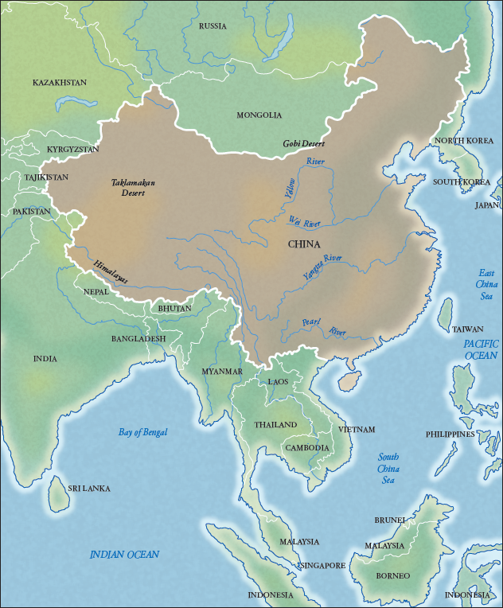
Source 16.1 China has an area of over 9.6 million square kilometres and is the world’s third largest country today, after Russia and Canada.

5 Using the map in Source 16.1 as a reference, identify the natural geographical boundaries separating China from nearby states in:
A the central north
B the west
C the south-west
D the east.

6 Which of these would have required additional human-made barriers to keep out neighbouring peoples?

7 Explain how China’s geography contributed to ancient China’s isolation.

